Baby is due on:
First day of maternity leave:
First day back from maternity leave:
Before birth
- My partner and I will attend an ABA Breastfeeding Education Class.
- I will join the Australian Breastfeeding Association, as my membership includes a copy of the Association’s book called Breastfeeding … naturally, member magazine Essence and access to local get-togethers run by trained breastfeeding counsellors and community educators.
- I will talk to my partner about how important breastfeeding is to me and our baby and how his/her support is vital to establishing and maintaining breastfeeding. I will discuss my intention to combine breastfeeding and work.
- I will establish the maximum amount of maternity leave available to me and assess how long it is viable for me to take leave for when taking into consideration my individual goals and financial situation.
- I will investigate childcare options and enrol my child at the one/s that suits my family best.
- I will speak to my employer and investigate a return-to-work policy that supports breastfeeding employees and the support they might already have in place.
- I will advise my manager or HR department of my intention to combine breastfeeding and work on my return.
2 months before returning to work
- I will establish the most effective way for me to manage breastfeeding on my return to work and define the support I need to achieve this
- If I need to express breastmilk while at work, I will plan how best to manage this.
- I will contact my employer to confirm my return to work date and discuss the details of my lactation breaks.
- I will decide on the best style of breast pump for my needs and decide whether to hire or buy one.
One month before returning to work
- I will sort through my work wardrobe to determine which options are best for breastfeeding/expressing at work.
- I will think about ways to get organised at home and how I can simplify things
One week before returning to work
- I will do a full practice run through my work morning schedule.
- If I plan to express breastmilk, I have estimated how much milk my baby will require and how this will be fed.
- I will create a list of people who can help me with questions and concerns.
- I will put in place strategies to ensure I maintain a healthy work/life balance and look after myself.

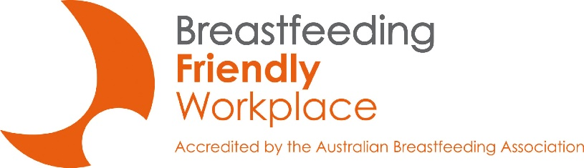
For more information about the Breastfeeding Friendly Workplace Program please contact:
bfwa@breastfeeding.asn.au

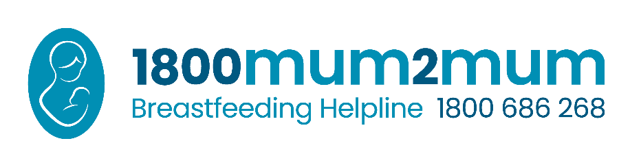

Sample letter to employer
Below is a sample memo/letter to tell your manager about your breastfeeding needs. Please feel free to adapt this to use your own words and relate it to your specific work situation.

Re: Breastfeeding Support in the Workplace
I am grateful for the support I have received throughout my [years/months] of employment with [organisation]. It has been an exciting time for my family and I as we prepare for the birth of our child. To ease my transition back into the workplace, I would like to discuss some arrangements that will allow me to continue breastfeeding after I return to work.
It is important for me to be able to continue breastfeeding when I return to work. Breastfeeding is recommended and supported by all health authorities because of the health implications for mothers and babies. Many organisations are now making it possible for women to continue breastfeeding after returning to work from maternity leave. I am hoping that we can agree on a plan that will allow me to breastfeed comfortably when I return to work. My immediate needs are:
1. Private lactation space with a lockable door and power point so that I can express breastmilk during the day. It only needs to be a small area to fit a comfortable chair and a small low table to place my equipment.
2. Access to a refrigerator to store breastmilk.
3. Flexibility to use break times to express breastmilk. I will need to express breastmilk about 2-3 times throughout an 8-hour workday, to prevent blocked ducts, mastitis, and maintain my milk supply. Expressing will take approximately 10-15 minutes (plus time to get to and from the lactation space). There may be occasions when I will need to express breastmilk outside of these allotted breaks. Would it be possible to use extra work time or discuss options for making up the time if necessary?
Knowing my organisation is making it possible for me to keep breastfeeding helps me feel more comfortable with leaving my baby to come back to work. I look forward to discussing this with you.
Sincerely,
[Insert your name]

