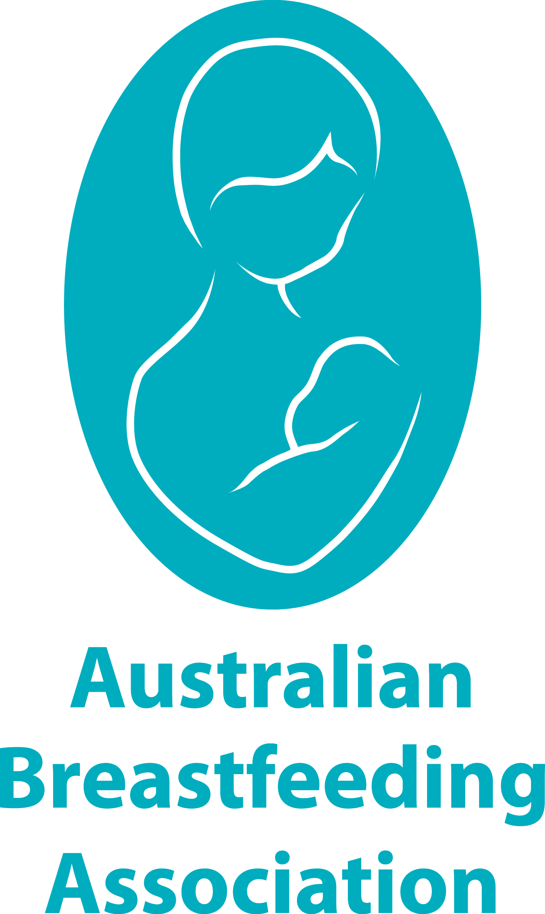
My Breastfeeding Plan

Having a breastfeeding plan can help you not only to work out what your preferences about feeding your baby are but also identify the people who will support your wishes.
ABOUT US
My name is:
My partner’s name is:
Our baby is due on:
BEFORE THE BIRTH
- I will talk to my partner about how important breastfeeding is to me and our baby and how their support is vital to establishing and maintaining breastfeeding.
- My partner and I will attend an Australian Breastfeeding Association (ABA) Breastfeeding Education Class.
- I will join the ABA, as my subscription includes a copy of the Association’s book called Breastfeeding … naturally, a quarterly magazine called Essence, premium access to the mum2mum app and access to local get-togethers with other parents run by trained breastfeeding counsellors and community educators. Many mothers find the most valuable part of being an ABA member is the mother-to-mother support they receive which assists them along their breastfeeding journey.
I will speak to my employer about a return to work policy that supports breastfeeding employees. This site has lots of helpful information.
IMMEDIATELY AFTER BIRTH (vaginal or caesarean)
The following preferences are possible if both you and your baby are well, whether you have a vaginal or caesarean birth.
- Please place our baby on my chest immediately after birth, with a warm blanket covering their body for warmth. Many hospitals now allow this in delivery room before the procedure is complete, if you have a caesarean birth.
- I would like our baby to remain with me on my chest to encourage them to self-attach for their first breastfeed (with assistance from me as I feel is appropriate).
- Please perform all essential post birth observations while our baby is on my chest.
- We would like our baby to be weighed after their first breastfeed, lying on their tummy on a warm cloth.
IF MY BABY OR I REQUIRE SPECIAL CARE AFTER BIRTH
- If I am unable to hold our baby skin-to-skin after birth, I would like my partner to hold our baby.
- I wish my breasts to be treated gently and only touched with my permission.
- If my baby cannot breastfeed within the first hour of birth, please assist me to hand express my colostrum every 2 to 3 hours, starting from within the first hour after birth (or as close to as possible), to stimulate my milk supply and for feeding to our baby.
THE EARLY DAYS
- I will breastfeed my baby according to their needs and will follow my baby’s feeding cues in terms of length and frequency of feeds.
- I will keep my baby skin-to-skin as much as possible for at least the first few weeks after birth.
- I would like to room-in with my baby at all times so that I can learn our baby’s feeding cues.
- I do not wish to bathe our baby for at least the first 48 hours after birth.
- I do not wish to wash my chest area for 24 hours after the birth.
- My partner and I will not wear perfume or use strong-smelling items for the first few days after birth.
- We do not want our baby to have artificial nipples (dummies or bottles) at any time. If alternative feeding methods of expressed milk are needed, we would like our baby to be fed using a cup, spoon or syringe.
- We do not want our baby to receive anything other than breastmilk unless medically necessary. If it is considered necessary, I would like to sign a consent form which indicates I have been given all the information I need to understand why supplementation is medically necessary.
- If there are concerns about my baby’s weight, I would like to try more frequent feeding and other strategies for addressing this, with supplemental feeds only to be given when medically indicated and after I have signed a consent form which states I have been given all the information about why supplementation is medically indicated. If supplemental feeds are required on a longer term basis, we would like to use a breastfeeding supplementer.
IF I NEED MORE INFORMATION OR SUPPORT
- I will remind myself that breastfeeding, although natural, is a learned skill.
- If I need information or support regarding breastfeeding, I know I can:
  - call the National Breastfeeding Helpline on 1800 686 268 which is available 24 hours a day, 7 days a week staffed by trained ABA counsellors
  - download the mum2mum app
  - use the LiveChat service via ABA’s website to contact a trained Australian Breastfeeding Association volunteer
  - check out the up-to-date information on the Australian Breastfeeding Association’s website, on the ABA’s mum2mum app and in the ABA’s booklets
  - contact an International Board Certified Lactation Consultant if I have problems that ABA counsellors are unable to help me with
  - contact my local Australian Breastfeeding Association group for support and friendship from other breastfeeding women and trained ABA volunteers.
Sometimes mums and bubs need a little help to get the hang of breastfeeding and sometimes problems do arise. With the right support at the right time, most breastfeeding problems can be solved. The Australian Breastfeeding Association is recognised internationally for providing mother-to-mother breastfeeding support and accurate and up-to-date breastfeeding information.

