Baby is due on:
First day of maternity leave:
First day back from maternity leave:
Before birth
- My partner and I will attend an ABA Breastfeeding Education Class.
Although natural, breastfeeding is a learned skill. Educational programs have been shown to be the most effective single intervention for improving breastfeeding initiation and duration. Research indicates that women who attend breastfeeding education classes before their baby is born are more likely to continue to breastfeed and have a more realistic and positive view of parenting.
- I will join the Australian Breastfeeding Association, as my membership includes a copy of the Association’s book called Breastfeeding … naturally, member magazine Essence and access to local get-togethers run by trained breastfeeding counsellors and community educators.
While your newborn baby has the in-built skills needed to breastfeed, new mothers gain skills to breastfeed from previous experiences watching other mums breastfeed. Many mothers say that, with hindsight, they would have benefited from attending ABA meetings before their baby was born. There is also good evidence that mother-to-mother counselling promotes the initiation and maintenance of breastfeeding.
- I will talk to my partner about how important breastfeeding is to me and our baby and how his/her support is vital to establishing and maintaining breastfeeding. I will discuss my intention to combine breastfeeding and work.
A vital source of breastfeeding support is your partner. His/her attitudes have been shown to be an extremely important factor in the initiation and duration of breastfeeding. You may find the article How long should I breastfeed my baby useful when clarifying your goals.
- I will establish the maximum amount of maternity leave available to me and assess how long it is viable for me to take leave for when taking into consideration my individual goals and financial situation.
The early months of breastfeeding are crucial to establishing a good supply of breastmilk and getting to know your baby. Returning to work in the first half of a baby’s first year is linked to reduction in breastfeeding duration. By accessing the maximum length of maternity leave that is appropriate for your family, you will be supporting the establishment of a breastfeeding relationship that will adapt easily to your return to work. Points to consider include:
- What is the maximum maternity leave I will be able to take?
- How old will my baby be when I return to work?
- What are the breastfeeding options at this age?
- Do I want to return to work gradually?
- I will investigate childcare options and enrol my child at the one/s that suits my family best.
In many places it can be difficult to secure a place with the carer of your choice. It is advisable to consider the options available to you and identify your preferred option as early as possible. Things to consider:
- Will my child be cared for by a childcare centre, family day care, family or another option?
- Would I rather it was closer to work or home?
- Are the carers familiar with handling expressed breast milk (EBM)?
- What is the carers approach to sleep and settling?

- I will speak to my employer and investigate a return-to-work policy that supports breastfeeding employees and the support they might already have in place.
Your direct manager or HR department should be able to answer questions relating to breastfeeding support in your workplace. Broadly speaking you are looking for the space, time and support that will enable you to successfully combine breastfeeding and work. Planning during pregnancy has been linked with a successful return to work and an improved perception of the levels of support provided by the employer. Things to consider include:
- Is my employer an accredited Breastfeeding Friendly Workplace?
- Does my workplace Enterprise Agreement refer to lactation or lactation breaks?
- Does my workplace have a Breastfeeding Policy in place?
- Does my workplace provide lactation breaks in addition to regular breaks? If not, are they willing to accommodate a reasonable request to implement these in line with anti-discrimination legislation?
- Does my workplace have facilities in place for breastfeeding and/or expressing breastmilk?
- Do I know any colleagues who have returned to work while breastfeeding who might be happy to share their hints?

- I will advise my manager or HR department of my intention to combine breastfeeding and work on my return.
Many women want or need to return to work after they have had a baby. With the right planning, information and support, combining breastfeeding with work is easily achievable. The Breastfeeding Friendly Workplace accreditation program is an initiative of ABA. Accreditation is given to workplaces that meet set criteria in relation to providing breastfeeding or expressing facilities, support for breastfeeding mums and flexible work options. If your workplace is not already accredited, why not provide them with information on the BFW Program today! Resources to support you when speaking with your employer include:
- BFW Fact Sheet: Approaching your employer
- BFW Fact Sheet: Your rights at work
- What does BFW Accreditation include?
2 months before returning to work
- I will establish the most effective way for me to manage breastfeeding on my return to work and define the support I need to achieve this
Being clear about your needs before approaching your employer will help you to feel confident if negotiations are required. Research has shown that exclusive breastfeeding at 6 months is more likely when an employer has policies in place that are supportive of breastfeeding so clearly communicating your needs will assist you to reach your breastfeeding goals. Things to consider include:
- How many days will I be working?
- How long will my workday be?
- Would a flexible approach such as a gradual return, part-time hours or working from home be suitable?
- How long will I be away from my baby and do I need to provide breastmilk for use during this time?
- How many feeds will my baby need during this time?
- What are my options for providing milk while I am at work? These could include breastfeeding around work, going to the child, having the baby brought to you or expressing breastmilk.

- If I need to express breastmilk while at work, I will plan how best to manage this.
Expressing breastmilk during the day requires some organisation and planning but it will soon become a habit that fits easily into your working day. Things to consider include:
- What are the best times to express breastmilk at work? Be realistic about the flow of your workday and be prepared to lock these times into your diary. Be flexible if adjustments are required to this initial plan once you are back at work.
- What space will I use to express breastmilk at work?
- Where will I store my expressing equipment at work?
- Where will I store my expressed breastmilk (EBM) at work?
- How will I transport my milk home from work?
- Where will I store the EBM that I bring home from work?
- Who can I contact for advice and support with expressing at work?

- I will contact my employer to confirm my return to work date and discuss the details of my lactation breaks.
Creating a supportive breastfeeding environment can deliver significant cost savings associated with improved retention rates, earlier return to work, duration of service and reduced recruitment and retraining costs. While many organisations are aware of this, they are unsure of where to start or how to provide effective support.

- I will decide on the best style of breast pump for my needs and decide whether to hire or buy one.
To express effectively you will need the most appropriate breast pump for your needs. The article Which breast pump is best for you? will assist you to identify the breast pump best suited to your needs.
- Many local ABA groups hire hospital grade breast pumps and members of the ABA receive a 50% discount on hire costs.
One month before returning to work
- I will sort through my work wardrobe to determine which options are best for breastfeeding/expressing at work.
It is best to think about what you will wear to work well in advance of your return date. Factors such as ease of access for breastfeeding/expressing, a change in shape or size, potential milk leakage and changing fashions could mean your old work wardrobe may need some tweaking.

- I will think about ways to get organised at home and how I can simplify things
Returning to work brings both rewards and challenges as the rhythm you have found to work for your family changes to accommodate your new situation. The ABA Booklet. Breastfeeding: women and work is a useful resource when planning your return to work. Things to consider include:
- How can I simplify my life at home?
- Can I delegate or outsource any responsibilities?
- What can I do now to prepare for when I return to work?

One week before returning to work
- I will do a full practice run through my work morning schedule.
It is advisable to have a practice of your planned morning routine prior to your first day back at work. Getting prepared and leaving the house as you intend to do each morning can alleviate the stress of your first day back. Things to consider include:
- How long is the trip to childcare at that time of day?
- How long will the childcare drop off take?
- When will I pack supplies such as nappy bags and lunches?

- If I plan to express breastmilk, I have estimated how much milk my baby will require and how this will be fed.
The amount of EBM required each day will depend on the age and feeding patterns of your individual child. On average a baby will consume approximately 800 mL of breastmilk in 24 hours from birth to 6 months. Although this amount may decrease once solid food is introduced this is not always the case. You can estimate how much milk is required based on baby’s age and current daily routine. Things to consider include:
- How many feeds does my baby currently have during my planned working hours?
- Am I planning to drop any feeds on my return to work?
- What will I use to feed EBM to my baby?
- If using a bottle, when will I introduce this?

- I will create a list of people who can help me with questions and concerns.
Returning to work from maternity leave is a big adjustment and understandably can be a stressful experience. Being organised with contact details such as your child’s caregiver, the Breastfeeding Helpline, who to speak to at work relating to breastfeeding support, supportive family and colleagues can be reassuring

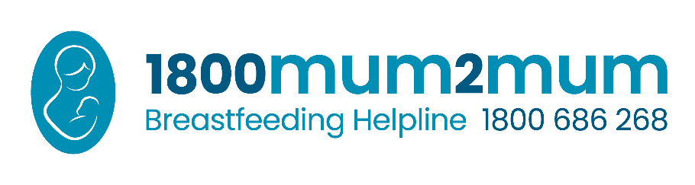
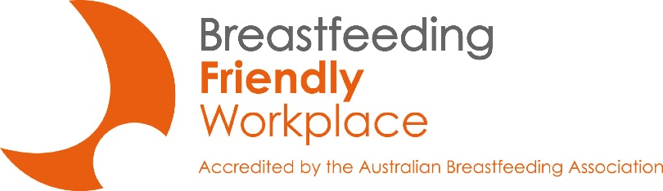
- I will put in place strategies to ensure I maintain a healthy work/life balance and look after myself.
For more information about the Breastfeeding Friendly Workplace Program please contact:
bfwa@breastfeeding.asn.au

Looking after yourself is important for your health and wellbeing. Returning to work will be a busy time and looking after yourself can easily be overlooked. Resources to assist you with finding a work/life balance that is right for you include:
- ABA Booklet. Breastfeeding: diet, exercise, sex and more
- ABA Booklet. Breastfeeding: women and work

Sample letter to employer
Below is a sample memo/letter to tell your manager about your breastfeeding needs. Please feel free to adapt this to use your own words and relate it to your specific work situation.

Re: Breastfeeding Support in the Workplace
I am grateful for the support I have received throughout my [years/months] of employment with [organisation]. It has been an exciting time for my family and I as we prepare for the birth of our child. To ease my transition back into the workplace, I would like to discuss some arrangements that will allow me to continue breastfeeding after I return to work.
It is important for me to be able to continue breastfeeding when I return to work. Breastfeeding is recommended and supported by all health authorities because of the health implications for mothers and babies. Many organisations are now making it possible for women to continue breastfeeding after returning to work from maternity leave. I am hoping that we can agree on a plan that will allow me to breastfeed comfortably when I return to work. My immediate needs are:
1. Private lactation space with a lockable door and power point so that I can express breastmilk during the day. It only needs to be a small area to fit a comfortable chair and a small low table to place my equipment.
2. Access to a refrigerator to store breastmilk.
3. Flexibility to use break times to express breastmilk. I will need to express breastmilk about 2-3 times throughout an 8-hour workday, to prevent blocked ducts, mastitis, and maintain my milk supply. Expressing will take approximately 10-15 minutes (plus time to get to and from the lactation space). There may be occasions when I will need to express breastmilk outside of these allotted breaks. Would it be possible to use extra work time or discuss options for making up the time if necessary?
Knowing my organisation is making it possible for me to keep breastfeeding helps me feel more comfortable with leaving my baby to come back to work. I look forward to discussing this with you.
Sincerely,
[Insert your name]

Wiles (1984) The effect of prenatal breastfeeding education on breastfeeding success and maternal perception of the infant. Journal of Obstetrics, Gynaecology and Neonatal Nursing 13(4): 253–-257; Duffy, Percival, Kershaw (1997) Positive effects of antenatal group teaching sessions on postnatal nipple pain, trauma and breastfeeding rates. Midwifery 13 (4): 189–196; Guise, Palda, Westhoff, et al (2003) The effectiveness of primary care-based interventions to promote breastfeeding: systematic evidence review and meta-analysis for the US Preventive Services Task Force. Ann Fam Med 1(2): 70–78.
Cox (2002) Breastfeeding: I can do that. TasLac, Tasmania; Brodribb (2004) Breastfeeding Management 3rd edition, Australian Breastfeeding Association 48; Palda (2004) Interventions to promote breastfeeding: applying the evidence in clinical practice. CMAJ 170: 976–978.
Bentley, Caulfield, Gross, Bronner, Jensen, Kessler, Paige (1999) Sources of influence on intention to breastfeed among African-American women at entry to WIC. Journal of Human Lactation 15(1): 27–34;Arora, McJunkin, Wehrer, Kuhn (2000) Major factors influencing breastfeeding rates: mother’s perception of father’s attitude and milk supply. Pediatrics 106(5): 1–5.
Smith JP, McIntyre E, Craig L, Javanparast S, Strazdins L & Mortensen K 2013. Workplace support, breastfeeding and health. Australian Institute of Health & Welfare: Family Matters, Canberra, 93.
Cooklin AR, Donath SM, Amir LH 2008, Maternal employment and breastfeeding: results from the longitudinal study of Australian children. Acta Pædiatrica 97:620–623
Coulson M, Skouteris H & Dissanayake C 2012. The role of planning, support, and maternal and infant factors in women's return to work after maternity leave. Australian Institute of Health & Welfare: Family Matters, Canberra, 90:33–44.
Smith JP, McIntyre E, Craig L, Javanparast S, Strazdins L & Mortensen K 2013. Workplace support, breastfeeding and health. Australian Institute of Health & Welfare: Family Matters, Canberra, 93.
Kent JC, Leon MR, Cregan MD, Ramsay DT, Doherty DA, Hartmann PE 2006. Volume and frequency of breastfeedings and fat content of breastmilk throughout the day. Pediatrics 117:(3):e387–e395

