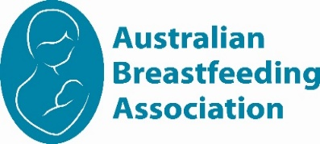
CityWest Group
Feb – Jun 2026
Calendar of events

Come along to one of our local meetups!
It’s always rewarding talking and listening to people about their families and experiences with their babies.
Whether you are awaiting the arrival of your first baby, breastfeeding or bottle feeding – all mothers, fathers, their children, support people and friends are most welcome to attend our meetings. Our meetings are very informal and while a nominated topic is set for most meetings, there is always an opportunity to discuss other topics of interest as a group or individually with a counsellor.
Email citywestaba@gmail.com
UNWELL CHILDREN AND ADULTS MAY NOT ATTEND MEETINGS
We look forward to meeting you.

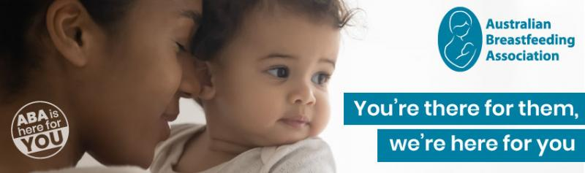
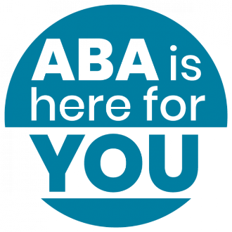

February – June 2026

Fri 6th Feb  10am – 12pm | Guest Speaker  Baby CPR  Skills session: Join Heidi, a paediatric nurse, for a session on baby CPR, allergies and choking | St Alban’s Church Community Hall  171 Great North Road  FIVE DOCK, NSW, 2046  RSVP essential to Nicola 0434 563 256
Wed 18th Feb  10am – 12pm | Expressing & Storing Milk  Do you have questions about expressing? How much? How long? How to store it? | Little B.I.G House  Flour Mill of Summer Hill16 Flour MI Way  Summer Hill, NSW 2130  RSVP to Eve 0405 096 580
Fri 6th March  10am – 12pm | Guest Speaker  Hannah, Speech Pathologist  Laying positive feeding foundations with your infant: the first year | St Alban’s Church Community Hall  171 Great North Road  FIVE DOCK, NSW, 2046  RSVP essential to Nicola 0434 563 256
Wed 18th Mar  10am – 12pm | Weaning  Why we might wean, how to go about weaning and how we might feel | Little B.I.G House  Flour Mill of Summer Hill16 Flour MI Way  Summer Hill, NSW 2130  RSVP to Eve 0405 096 580
Fri 1st May  10am – 12pm | Sleep and nighttime parenting  Sleeping like a baby, what does that really mean? | St Alban’s Church Community Hall  171 Great North Road  FIVE DOCK, NSW, 2046  RSVP to Regine 0403 414 111
Fri 8th May  10am – 12pm | Cuppa & Chat  Celebrate National Mothering  Week! Let us buy you a warm or  cold drink while you connect with other parents | Petersham Park Playground  Splash Café at the pool  RSVP essential to Nicola 0434 563 256
Wed 20th May  10am – 12pm | Guest Speaker Dympna  Circle of Security  How to build secure attachments with our children | Meet at Little B.I.G House  Flour Mill of Summer Hill16 Flour MI Way  Summer Hill, NSW 2130  RSVP to Eve 0405 096 580
Fri 5th June  10am – 12pm | Self-care for breastfeeding mums  Join us as we share ideas on taking care of ourselves as we take care of our babies | St Alban’s Church Community Hall  171 Great North Road  FIVE DOCK, NSW, 2046  RSVP to Regine 0403 414 111
Wed 17th Jun  10am – 12pm | Feeding Patterns – what’s normal?  Join us as we chat about  what’s normal at various ages | Meet at Little B.I.G House  Flour Mill of Summer Hill16 Flour MI Way  Summer Hill, NSW 2130  RSVP to Eve 0405 096 580
FIND US ON Facebook | Australian Breastfeeding Association Inner West Sydney Groups  ABA Inner Metro Sydney | www.breastfeeding.asn.au

CityWest Group Leaders & Breastfeeding Counsellors:

Nicola 0434 563 256
Regine 0403 414 111

Breast Pump Hire:

Holly 0423 684 216
Kate 0499 071 510

Breastfeeding Counsellors:

Eve 0405 096 580

CityWest Library:

citywestaba@gmail.com
Mother Safe Medication Info Line:
93826539

Poisons
Information:
13 11 26

Breastfeeding Helpline
1800 686 268
The Breastfeeding Helpline is supported by funding from the Australian Government

www.breastfeeding.asn.au

