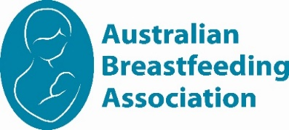
Illawarra 2026
Calendar of events

Tue 28 April 1030am | Sleep and nighttime parenting |  |  | Dapto
Friday 8th May 10am | Celebrating Mothers/Grandmothers  National Mothering Week celebration |  |  | Thirroul
Tue 26 May 1030am | Starting Solids |  |  | Dapto
Friday 12th June 10am | Self-care for feeding mums |  |  | Thirroul
Tue 23 June 1030am | Slings and Baby Carriers |  |  | Dapto
Friday 17th July 10am | Starting Solids |  |  | Thirroul
Tue 28 July 1030am | Supporting each other as parents |  |  | Dapto
 | www.breastfeeding.asn.au
Please check for any changes of date/venue on Facebook
ABA Illawarra
https://www.facebook.com/BreastfeedingIllawarra
Catch Up’s
2nd Friday of the Month
Club Thirroul
2B Station St, Thirroul NSW 2515

4th Tuesday of the Month
Dapto Citizen Bowling Club
102-104 Fowlers Rd, Dapto NSW 2530

Whether you are awaiting the arrival of your first baby, breastfeeding or bottle feeding – all mothers, fathers, their children, support people and friends are most welcome to attend our meetings and social gatherings. Our meetings are very informal and while a nominated topic is set for most meetings, there is always an opportunity to discuss other topics of interest as a group or individually with a counsellor.
Our group meets at Club Thirroul the 2nd Friday of the Month and Dapto Citizens Bowling Club on the last Tuesday of the Month .

See the ABA website calendar for information about face to face meetings offered by groups around Australia
We look forward to meeting you. Naomi, Candice, Isabelle and Rosemary, ABA Illawarra Team

North Western Sydney Region 2020-21
Calendar of events

Illawarra Group Leader

Naomi
0494570521

illawarraaba@breastfeeding.asn.au

Mother Safe Medication Info Line 9382 6539

Poisons Information
13 11 26
Breastfeeding Helpline
1800 686 268
The Breastfeeding Helpline is supported by funding from the Australian Government

www.breastfeeding.asn.au

